Case Competition Executive Summary
  - Justin Shockley, Alan Lin, Tim Thomas, Nithin Kommineni, Miles Parker
Business understanding and Exploratory Data Analysis
The business problem is to successfully identify what customers are likely to churn and what the major factors driving this are. This matters because it costs much more to acquire customers than it is to retain customers. If we can successfully predict who might churn, then we can employ targeted strategies, using insights from modeling, to retain those customers.
During our pre-model exploratory data analysis, we first needed to see how many observations there are, what our predictor variables are, and what our response variable is. There are 5636 observations with 36 total variables. 33 are predictor variables and two are reference variables (unique identifiers). Our response variable in this dataset is left_flag and this represents whether a customer will churn (“yes”) or not (“no”). We examined the distribution of this variable and found that about 75% of responses were “no” and 25% “yes”. We then examined the dataset for missing values and NULL values. We found that the recent_offer column has 3106 missing values. This can skew/misrepresent the data and can impact our ability to find a relationship between Recent Offers and customer churn. Internet_tech has 1212 missing values. This may mean that the customer does not have internet or the equipment for internet. We noticed that every value in the fiscal_qtr column was “Q3” which shows no variation within the column.
Data Preprocessing and Feature Engineering
We removed columns that were unique identifiers because they add no value to predicting customer churn. They are simply keys to identify each row. Since we are looking at the data at large and not individual observations, we can remove these columns. The two columns being removed for this are acc_ref and cus_ref.
We also removed columns that were missing over 50% of data. There is only one column in this data that fits this and it is recent_offer. Recent_offer has over 55% of its data missing, making this column unusable. This column adds no value to our model since most of the data is not there.
Next, we imputed the remaining missing values. There were 1212 (out of 5636) missing values in internet_tech, which is a categorical variable with three categories. We imputed the missing values with a new category, “Unknown”. There was not enough data missing for us to take the column out completely, but we must make all the data we have usable, so we added this “Unknown” category. This gives our model a better understanding of how internet technology of users can potentially affect churn.
For our next imputation, we had to account for eight missing values in total_billed. Since so few values were missing and the column is numeric, we can impute these values with the median of the column. We chose the median instead of the mean because after viewing a boxplot of the distribution of total_billed, we can see that it is skewed. This can affect the mean value so going with the median will be more robust.
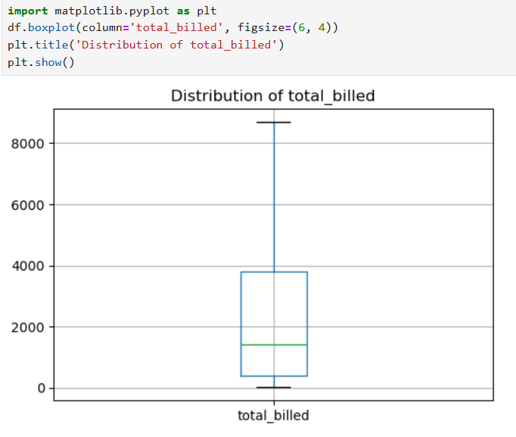

We removed fiscal_qtr as well because there was no variation in that column. Every single row has “Q3” as an entry so this column means nothing to us in predicting customer churn.
We engineered a new feature that is average monthly spent (avg_monthly_spent). This new column is total_bill divided by tenure_mo, so it takes how much someone has been billed in their time with the company divided by how long they have been with the company. This can give us a clearer picture of how much people are paying monthly throughout their tenure with the company.
Our next feature is combining the data from stream_tv, stream_movies, and stream_music into one column that is the sum of how many streaming services are attached to their account. The range for this is 0 to 3, 0 being no streaming services and 3 being they have all of them. This will give us a good idea if what type of individual streaming service affects churn, or if the number of streaming services affects it. We repeated the same process from streaming services for add-ons. We created a column that shows how many add-ons an account may have. After creating these aggregate features, we are going to remove the specific types of streams and add-ons. At first, our thinking was to keep all columns in case the type of service was a factor towards customer churn. However, after creating the bar charts shown below, we found that no matter the type of service the customer was receiving, they all show that customer churn was lower. Since having additional services can be correlated with lower churn, we know we can remove these columns because we aggregated them into separate columns.
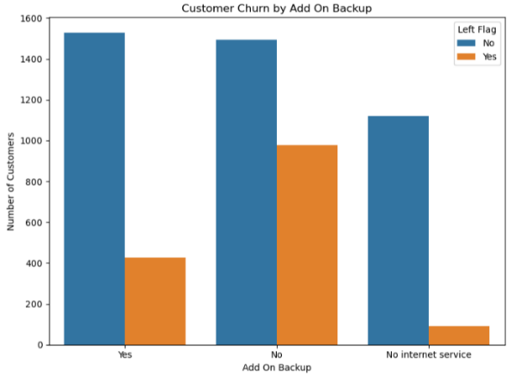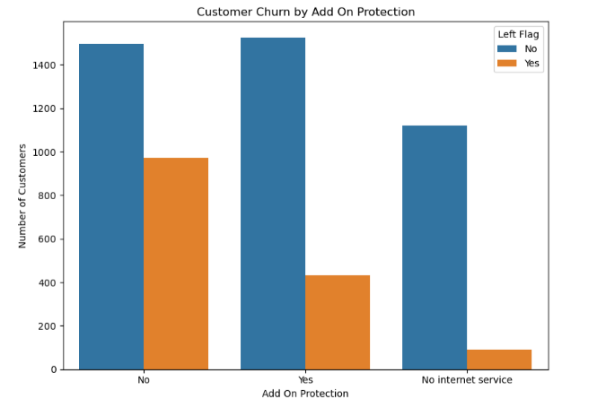
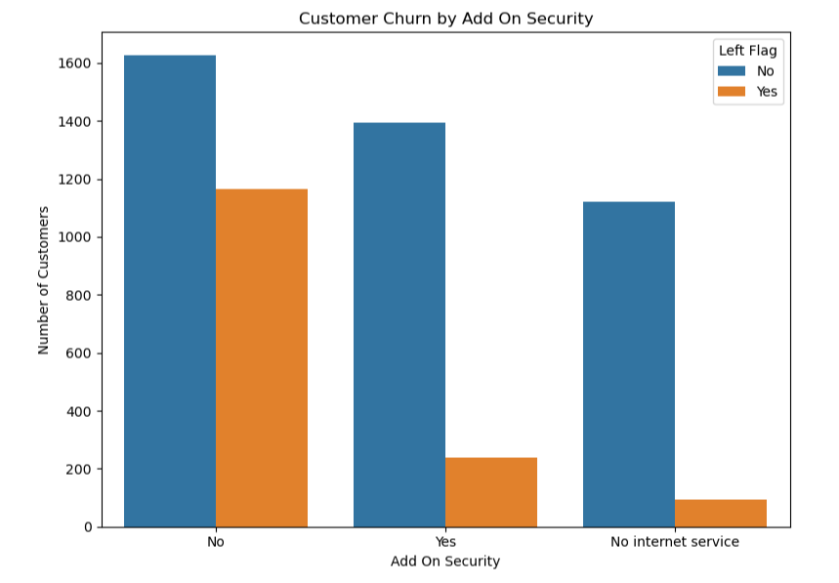
Lastly, we added a new column that groups people into categories based on their tenure_mo. That way we can segment people based on how long they’ve been with the company. We can look at each segment under a microscope and see trends happening within the segment. We created three bins: “Under 2 Years”, “2-4 Years”, and “Over 4 Years”.
Predictive Modeling
We ran 3 different models XG Boost, Lasso Logistic Regression and Random Forest.
We started with the Random Forest model which led to a score of 0.8774. This would prove to be the lowest AUC score of the different models. It does have some strong benefits like its ability to handle nonlinear relationships and reduce overfitting. We did not choose this model because the AUC score was the lowest.
Lasso Logistic Regression proved to have a more impactful score and was tied with the XG Boost until we did more feature engineering. This model gave this model an AUC score of 0.888. This model is useful because of its ability to show direction and the ability to penalize coefficients to reduce their impact.
We had the best success measured in the AUC score of 0.903 with XG Boost Model. This model used a cross-validated grid search on the training data. This would allow the model to test multiple parameter combinations and refit the model using the best parameters. This model also allows us to restrict how complex the tree could become with parameters like Max depth, a learning rate and Subsampling.
Our top 5 predictors churn became:
- Fiber Optic
- Month-to-month
- Tenure under 2 years
- No Tech Support
- Contract term of 2 years.
Mechanics and Evaluation
Our basic post analytics used a stratified cross-validation to the tune of the model. It allows use to keep the same churn rate as the full data set. We noticed that 26.5% of the Left_flag churn rate did churn while 73.5% did not. The churn is unbalanced at 26.5%.
Recommendations
We focused our recommendations on three topics: Fiber Optics, Add-ons, and Referrals.

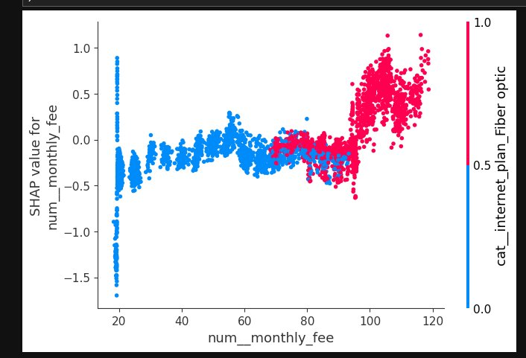
Fiber Optics
Fiber Optics is our focus because of how product pricing places it primarily in the high churn portion. The pink portion above shows that the fiber optic category is primary in the high churn zone with most of the plots placed in the upper high churn portion. This change happens around the $100 mark.
We believed that this meant that it needed to be marketed in a different fashion than DSL and other products. We believe that the marketing needs to be pushed towards businesses and people with home offices with a strong need for the benefits of fiber internet. These benefits include High Reliability/Stability, Lower Latency and symmetrical upload/download speeds.
Additionally, we want to make customer service more direct and allow better referral rewards with the high-end service to keep up with the luxury pricing of Fiber Optic internet service. This would increase the perceived value that the customer has with the business and overall increase the number of referrals.
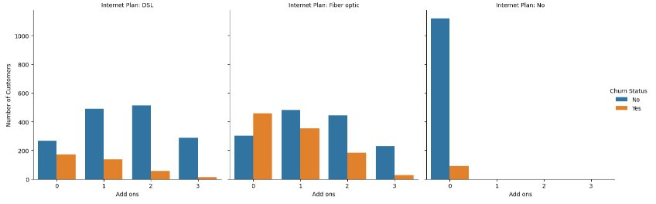
Add-On Products
We noticed that when we compared the portion of people with Add On products with additional products to the internet service had a higher cost to leave. This meant that their churn rate also decreased in proportion. This was the same with DSL, Fiber, and people with no internet service.
Our recommendation here was to increase the sales pressure on additional products to the base of internet service. These services could be phone, security, or other upgrades that could be bundled to a lower overall price than what the person might be paying currently.
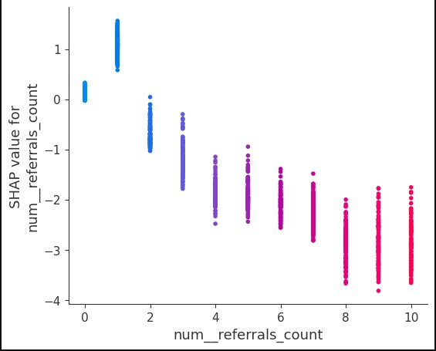

Referrals
Our last recommendation is to increase the focus on customer referrals. It costs less to retain customers then it would convince others to join. This would go along with the other recommendations above. We noticed that an increase in referrals from the customer means a strong decrease in the amount that is churning. We believe that incentives like Cash Rewards, Discounts, Exclusive Access and Upgrading would increase referrals. Additionally, we need to increase our focus on better customer satisfaction.

